**Purpose of Today’s lab:**

(1) Learn how to handle random errors of measurement with simple the statistical analysis

(2) Learn a means of solving a system of equations using Excel.

(3) Set up a system of equations using Newton’ 2nd Law for an accelerating mass with multiple forces on it.

As we review the steps in setting up the solution to problems involving a system of forces using Newton’s 2nd Law we will learn to use the equation solving capabilities of Excel. We will then check theoretical and numerical work with an experiment, and use statistics with Excel to gauge both the accuracy and precision of the experiment.

The experimental work is to give you an intuitive feel for Newton’s second law by showing you that forces are associated with accelerations, not with velocity or speed, and to give a quantitative means of assessing acceleration.

You will use low-friction carts rolling on an aluminum track along with motion and force sensors. You will set up a ramp and cart system as shown you in the classroom.

**Discussion of Accuracy, Precision and the “Variance”, “Standard Deviation”, or root-mean-square errors:**

**Precision versus Accuracy**: Here’s a dumb joke: A physicist, an engineer and a mathematician do a little archery practice with bows and arrows of their own design and manufacture. The target is 50 yards away. The physicist shoots first and misses the target center to the right by a foot. The engineer shoots next and misses by a foot to the left. The mathematician jumps for joy and says, “Hurrah – You shot a bull’s eye!”. The shooting was “Accurate”, because on average, the center of the target was “hit”, but the archers’ measurement of the center by this method was very imprecise! *Accuracy* in an experiment tells you that on average your measurements are somehow centered on the “true” value. *Precision* tells you how close, on average, the measurements are. It is possible to have high accuracy, but low precision, such as in the case of the stupid joke we started with. On the other hand, it is possible to have poor accuracy and high precision. For instance, imagine an archer shooting at the same target 50 yards away. Suppose he puts every arrow he shoots within a disk the size of your hand, but that the cluster of arrows he shot was a good 2 feet away from the center of the target. That would be high precision, because the certainty of any one shot landing close to its neighbors is high, but the accuracy is terrible. In simple terms, the precision you report is related to spread of measurements, or the uncertainty in any one measurement, and doesn’t have anything to do with the accuracy per se. It would be nice to have both high accuracy and high precision, but in any case, it is always the responsibility of the experimenter to report as best he or she can what sort of precision and accuracy is expected in the experiment performed.

Precision is reported in part by the number of significant figures you record. For instance, if you measure the length of a table and report it as 1.476351 meters, you are implying that you have knowledge of the length of the table down to a millionth of a meter! That would be a high precision measurement indeed. More likely, with the use of a meter stick, you’d want to report a length of 1.47 or 1.476 meters. Reporting 1.47 meters would imply that you could reliably measure the length to the nearest centimeter. Reporting 1.476 would be 10 times more precise and imply that you were certain down to the last millimeter. It would be nice, however, to have both high accuracy and high precision. In fact, the more usual way to report a simple case like the length of the table would be to say that the table is something like 1.476 +/- 0.003 meters. The last number, “plus or minus 0.003 meters” says my precision is good to about 3 millimeters. The table might be 1.479 meters or 1.473 meters. You really can’t be sure.

(Social comment: Mark Twain once commented that there are three kinds of lies in order of severity, the plain lie, the damned lie and the statistic! Be wary of numbers that you read or hear about in the news! Are they accurate? With what precision can you assess them? Even in the New York Time, errors in decimal places are common!)

**Random Errors:** In principle, random deviations from a “true” value should cancel out over many repetitions of an experiment, provided that there are no systematic errors. Systematic errors can’t be compensated for it any one experiment. Systematic errors result from biases in the equipment. But random errors or variations in measured values can be treated. To know whether or not a measurement is “good” one needs to know in some statistical sense how close to the “true” (but unknown) value a measurement is. One hopes that the average value of any set of measurements is close to the “true” value. This is often the case provided there are no unforeseen systematic errors. The average value of a measurement, *x*ave, is simple to calculate. Just add up all the values and divide by the number of measurements. That is

*x*ave = (*x*1+*x*2+*x*3+*x*4+ etc.)/*N* = i *x*i/*N*,

where *x*i represents each one of the *N* (total) measurements. But this doesn’t really tell us how much confidence we can have in any one measurement. Only by examining the precision or the spread of measured values around the average we can say something about how good any one measurement might be. One might be tempted to look at the difference between the average value obtained and any one measurement (*x*i-*x*ave) and then progressively add these errors over all the measurements to characterize the spread in errors. The problem with this approach is that if the errors are truly random, the sum of the differences between the average and the measurements will be zero because there will be as many positive differences and negative ones. So instead of adding the difference between the average and the measurements, we add the squares (so they’ll all be positive) of these differences and divide by the number of measurements minus one, *v* = 2 = i(*x*i-*x*ave)2/(*N-1).* This sum, *v*, is called the “variance”, and the square root of the variance is called the “standard deviation”, . This latter quantity is what is usually reported for experimental results and tells you about the precision of the measurement.

The standard deviation,  , gives a good idea of the spread of values you can expect to measure in a similar experiment. The smaller the standard deviation, the less the random errors you encounter and the “better” the measurement.

To highlight the formula:

Variance = *v* = the square of the standard deviation = 2 = i(*x*i-*x*ave)2/(*N-1)*

In Excel, the command to find the average is simply: =average(Range).

The Excel command for standard deviation is =stdev(Range).

The “Range” is just the limits of the column of numbers you are using. If the data were in cells D10 to D20, then the Range would be D10:D20.

The standard deviation  would be the experiments expected “error”, in that 95% of the measured values would be expected to fall with in 3 of the average value x*avg*.

An example of a set of data is given in the figure below. It shows a set of 10 measured values for the acceleration of a cart being accelerated by a falling mass. Column B contains the measurements. Column D contains the a running total of the deviate values (*a*i-*a*ave)2. The cell B15 has the value *a*ave and the cell D16 contains the square root of the final sum of (*a*i-*a*ave)2 divided by the number of points, *N*, giving the value **, the standard deviation or expected error for our measurements of acceleration. I would report my acceleration as a = 1.207 +/- 0.008 m/s2. A more conservative reporter would probably give the number as a = 1.21 +/- 0.01 m/s2. The “Standard Deviation” is used to calculate other statistical properties such as is performed in a “Chi-squared test”. In any case, the smaller it is in comparison to the average value measure, the more precise the measurement.

We will continue looking at statistical analysis and consider the importance of proper use of significant figures in later labs and consider the importance of “error propagation” in carrying out calculations. For this week, however, we concentrate on just finding the standard deviation:

**Systematic Errors:** What if your experimental set up has flaws. These are errors that you may or may not be aware of, but in principle you can eliminate most of these errors by careful construction of your experiment. For instance, what if the motion detector were 5 percent off in how it was calibrated for the speed of sound in the room? You could seemingly get “good data”, and be unaware that your values were systematically off. In general, the only remedy for systematic errors is to look for other independent ways to measure the same physical quantities, and to repeatedly check the calibration of the equipment that you use. If you suspect the existence of a systematic error, you should devise a way to isolate it or cancel it, or find an entirely different means of measuring what you want to know. Perhaps you would use a different set of equipment to perform the same experiment, or completely revise your experimental procedures.

**Illegitimate Errors**: These sorts of errors are in part, bad, careless technique and in part, poor equipment setup. For instance in this lab you will use a hanging weight to pull on a cart. How you think the measurements would be affected by having the weight on the end of the string swing? This would be an error easily avoided by careful technique. You may well have many such errors that are “unnecessary” if proper care is not taken. The adage, “measure twice, cut once” is to help remind us to avoid this sort of carelessness. Look for ways today to improve your technique.

**Random Error analysis**: In practice, no two measurements of any experiment are precisely the same. There are slight variations in the system being measured or other conditions, stray voltages in sensors, maybe a butterfly flapped its wings in the pacific giving rise to a breeze the flutters through room, any number of things lead to variations in measured values. Even with no identifiable outside influences, there will be a statistical fluctuation in the distribution of measurements.

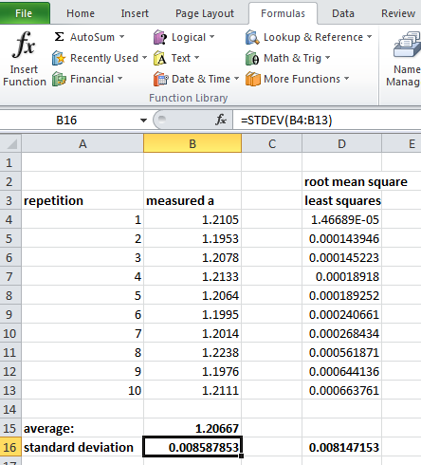

These types of variations are NOT errors, per se. They are the unavoidable consequences of naturally variations inherent in the process. The simplest means to deal with and characterize random errors is to find the average value of the measurement and define the statistical deviation away from that average. Error analysis is trivial to do in Excel. As described above Column B contains 10 measured acceleration values of a car being pulled up a ramp by a falling mass. The 10 measured values are in cells B4 to B13. The setup for each measurement was (monotonously) the same. (Note: You will produce similar data – but follow what I have done with my data here.) The average in B15 is defined simply as “=average(b4:b13)”. The “Standard Deviation” or natural spread of numbers around the average is in B16, and is defined at “=stdev(b4:b13)”.

In column D we calculate the standard deviation “by hand”. For instance, D4 = (B4-$B$15)^2. This gives the square of the deviate. This formula is copied down to D13. D16 = sqrt (Sum(D4:D13)/9). You will analyze variations in your measurements this way!

**Next topic: Numerical Skills and Solving systems of equations**. Suppose you have a system of 3 equations in three unknowns. Let’s start with a specific example:

x + 3y + z = 1

y + 6z = -1

3x + 2y + z = 0

The standard way to solve this is to make a matrix of the coefficients of x, y and z, and write this as a matrix problem.

We’ll call the matrix coefficients, “M”, and let’s call the array of variables, x,y,z “X”. Finally, we’ll call the left-overs on the right hand side, “B”. Then our system of equations can be written as MX=B. If we define M-1 to be the inverse matrix of M, then M-1M=1. So multiplying both sides of the equation by the inverse matrix gives M-1MX= X =M-1B and the solution to our equation, for x,y, and z can be written, X = M-1B. I’ve explicitly calculated the matrix inverse below, and show that X = M-1B gives the answers for x, y and z.

Computers (or calculators) take care of all these calculations for you. You really only need to input the matrix M and B, and the computer or calculator does the rest.

We are going to use Excel to do this for the physics problem from today’s lab. To get ready for that, please go through this example problem to learn how to do it yourself.

Please examine the figure below. It shows you how to solve the problem I have just outlined. Please pay special attention to the instructor as he or she tells you how to use the “MINVERSE” (matrix inverse) and “MMULT” (matrix multiply) commands.

The important pieces of the spreadsheet calculation shown are these:

(1) The matrix of coefficients was put in cells A8 to C10. The matrix “ B”, or right-hand side values were put in cells E8 to E10. Then

(2) The MINVERSE(A8:C10) was used to place the first element of the inverse matrix in cell A14. To fill out the rest of the inverse matrix, the cells A14 to C16 were highlighted. , and the “F2” key was hit to tell the spreadsheet that the cells have a specific formal-format coming. Then Shift-Ctrl-Enter was hit to paste the MINVERSE elements into the whole matrix.

(3) Finally, the MMULT(A14:C16,E8:E10) was put in cell F14 to which set the first element of M-1B there. This is the “x” value. Then the cells F14 to F16 were highlighted, and “F2” was pressed, followed by “Shift-Ctrl-Enter” to fill out the answers x,y,z.

TRY THIS YOURSELF TO COMFIRM IT WORKS!!! WHY NOT TRY IT AT HOME BEFORE YOU COME TO LAB?

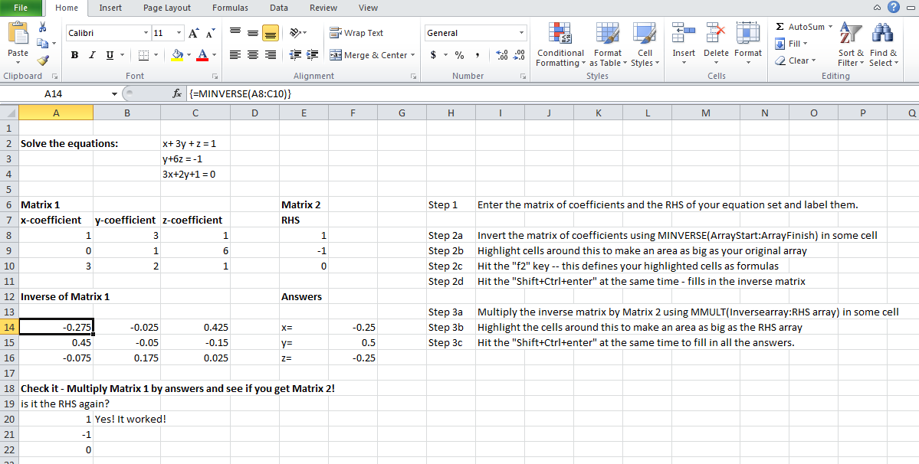

Once you have this template, you can use it to do other problems, such as those in today’s lab.

**Let’s move on to the physics of today’s lab:**

**The basic idea**: Newton’s laws do ***NOT*** tell us about the velocities of objects. Instead, they tell us about their ***changes in velocity***. There is a common sense, simple language statement for Newton’s second law. It is:

Nothing can change its speed or direction unless an unbalanced, net force, ***F***, acts on it to change that motion. If there is a net force on an object, then its velocity ***must*** change – it has no choice! The rate at which the velocity of the object changes (acceleration) depends on how big the force is, and how massive the object is. The bigger the force, the bigger the change in velocity. On the other hand, the bigger the mass, the smaller the acceleration. This is a statement of cause and effect. Forces cause changes in motion. Accelerations are the effect.

When one writes those last words as a formula, one often names the net force *****F*** to remind everyone that the net force is the sum over all forces acting on any one object. Calling acceleration ***a***, and mass, *m*, then the best way to write Newton’s second law is actually:

***a*** *= ****F****/m (a change is velocity happen when a net force is on m, but is smaller if m is bigger)*

We use bold-face type to indicate that both the acceleration and force are vectors. That means that direction counts! If you push up, then the acceleration has to be up – if you push to the East, the acceleration has to be to the East, etc. It would be entirely counter to Newton’s laws and an affront to the universe in general, if you pushed up, and something accelerated downward, or you pushed to the South and something accelerated up, or something crazy like that. In this lab, we simplify the situation by examining forces and acceleration in one direction only.

What will are doing today is similar to last week’s lab, but we are going to add an extra force, so that the sum of the forces is a little more complicated than it was last week.

The acceleration, **a** = **v**/t does not give us the velocity! It only tells us what the changes to the velocity are. If we are given the velocity at a point in time, we can add the changes in velocity to determine what the velocities will be after this point. But it is important to understand that Newton’s second law applies, moment by moment, to tell us only ***changes*** in velocity, and not to the particular value of velocity, itself.

Newton’s first law is a special case of the second law, F = 0, so there can be no acceleration and the velocity of an object cannot change.

**Activity 1. Acceleration of the cart by dropping a mass over the side of the track.**

In this activity you will predict the acceleration of the cart and then compare it to the measured value.

**Setup**: Consider the figure below: It illustrates the set up that you will use to predict and then measure the acceleration of a cart on a ramp.

Tilt your ramp up at some convenient, steady angle **. Attach a pulley. Get a cart (labeled m1 in the figure), string, a hanging mass (labeled m2 in the figure) and motion detector. Put the motion detector at the base of the track. Use the mass scale to obtain the mass of the cart, and record it and the value of the hanging mass you have chosen.

Measure the sine of the angle, sin**, at which your track is tilted. Since we have just discussed experimental error, include an error estimate of your angle. Do this by finding the height, h, of some point of the track, and the hypotenuse formed from the base of the track to that point where you measured the height just as we did last week. Then sin* *  = h/hypotenuse. Repeat this or a similar measurement 10 times. Record these values in an Excel Spreadsheet, and then find the average value sin(** )*avg* and the standard deviation of this measurement ** . **Copy and paste your spreadsheet work to an open Word Document and highlight your average value for sin(** ).**

Also record the values for the mass of y our cart and the value of the mass that you will hang from the pulley. We will assume for the simplicity of the lab that these masses are recorded with “infinite” precision! (That, by the way, is now a known systematic error! Other systematic errors are things like neglecting the motion and mass of the pulley and the mass of the string, etc. See if you can think of some others.)

Mass m1: ______________ (kg) Mass m2: _____________(kg)

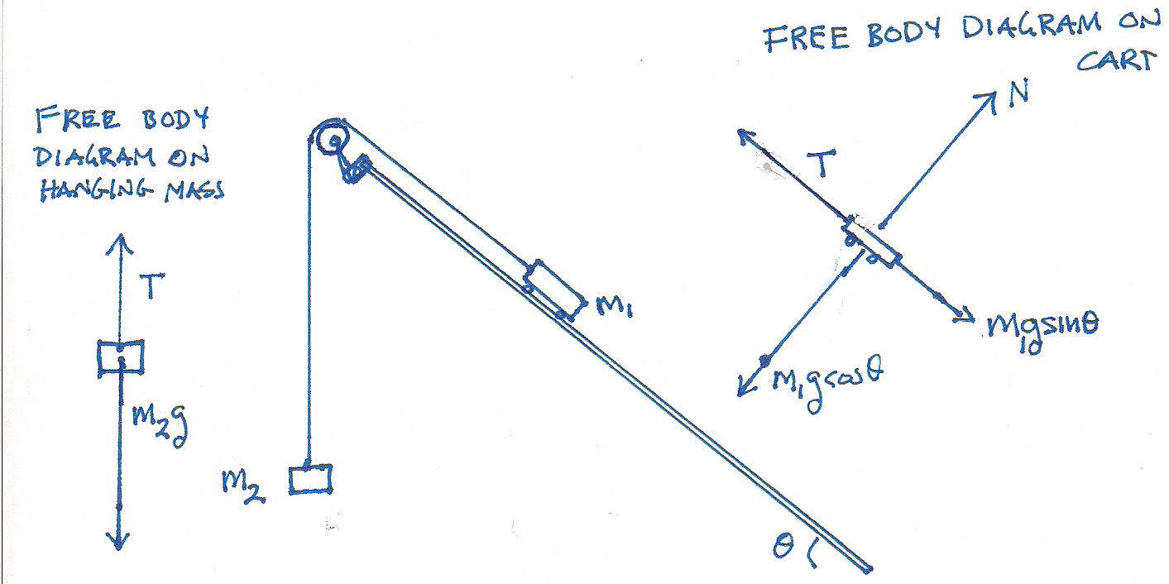

Attach m2 to the end of the dangling string such that the string can pull the cart about a meter or so before hitting the ground. Practice letting the falling mass accelerate the cart before you begin to take measurements. In order to get a good measurement, you will need to coordinate with your lab partner.

**Prediction:** To predict the acceleration, apply Newton’s second law to each mass, m1 and m2, separately. (Refer to the free body diagrams that have been provided for you.) You can neglect the mass of the string, and likewise, neglect any friction between the cart and the track. For m1, let the x-axis run along the ramp, and the y-axis run perpendicular to it (as suggested in the figure). Label the tension in the rope “*T*”. Please understand that the function of the pulley is to re-direct the force, so that the tension both pulls up on m2 and pulls along the ramp on m1, but the magnitude of the tension is the same everywhere along the string. You also need to understand that the magnitude of the acceleration of m1 is the same as that of m2, but these accelerations are in different coordinate systems, so be careful of the algebraic sign.

Working with your lab partners, determine the sum of the forces on the masses using Newton’s second law for m2 in the vertical direction and again for m1 in the x-direction along the track as symbolic equations (**no numbers – just symbols! -- and BE CAREFUL ABOUT THE SIGNS**.) **Write your equations in a Word Document in the form suggested below where :**

(1) m2 *a* = sum of the forces on mass 2! = a function of T, g and possibly other stuff

(2) m1 *a*  = sum of the forces on mass 1! = a function of T, g, * *and possibly other stuff

You now have two equations in two unknowns. The unknowns are the magnitude of the acceleration, *a*, and the magnitude of the tension, *T*. *Rewrite* these equations in form of the matrix equation:

Where A, B, C, D, E and F are constants that are determined from the analysis you just completed, and *a* and *T* are your unknowns. Once you have done this symbolically, put in your numbers into the equation and use the Excel spreadsheet with the MINVERSE and MMULT command to solve for *a* and *T*. We will not make use of our knowledge of *T* in this lab but record it anyway.

Do all your work in an Excel worksheet. **After you are done, copy and paste your matrix Excel worksheet to your Word document and record your predictions**:

Predicted: ***a(predicted)*:** ______________(m/s/s) *T(predicted)*: _______________(N)

**Now do the experiment.** Use LoggerPro’s Analyze, linear-fit function to fit the appropriate part of the velocity curve for each repetition of the experiment. Use the value for the slope, m, as the measure of the acceleration. The figure below shows an example. Also shown is a fit to the position graph. The acceleration is twice the value of the constant “A” in that example as you learned last week. The percent error is defined as

% Error = |((prediction-measurement)/measurement)|*100%. Record that too.

Record the values of your masses in suitable cells that you can reference in your Excel spreadsheet. Use units of kilograms. Record the angle of the ramp and the predicted value of acceleration.

**Measure your acceleration 10 times, and record the values in Excel with the percent errors.**  Put the measured accelerations in Column A, and the calculated percent errors column B. Put the square of the deviates in column C and explicitly calculate the standard deviation as was done in the example above. Calculate the average and standard deviation of the acceleration and report them in your Word Document. Copy and paste the figure from your LoggerPro program into your Word document. It should look similar to the one below. **When you have finished your analysis copy and paste your data and analysis to the Word Document.**

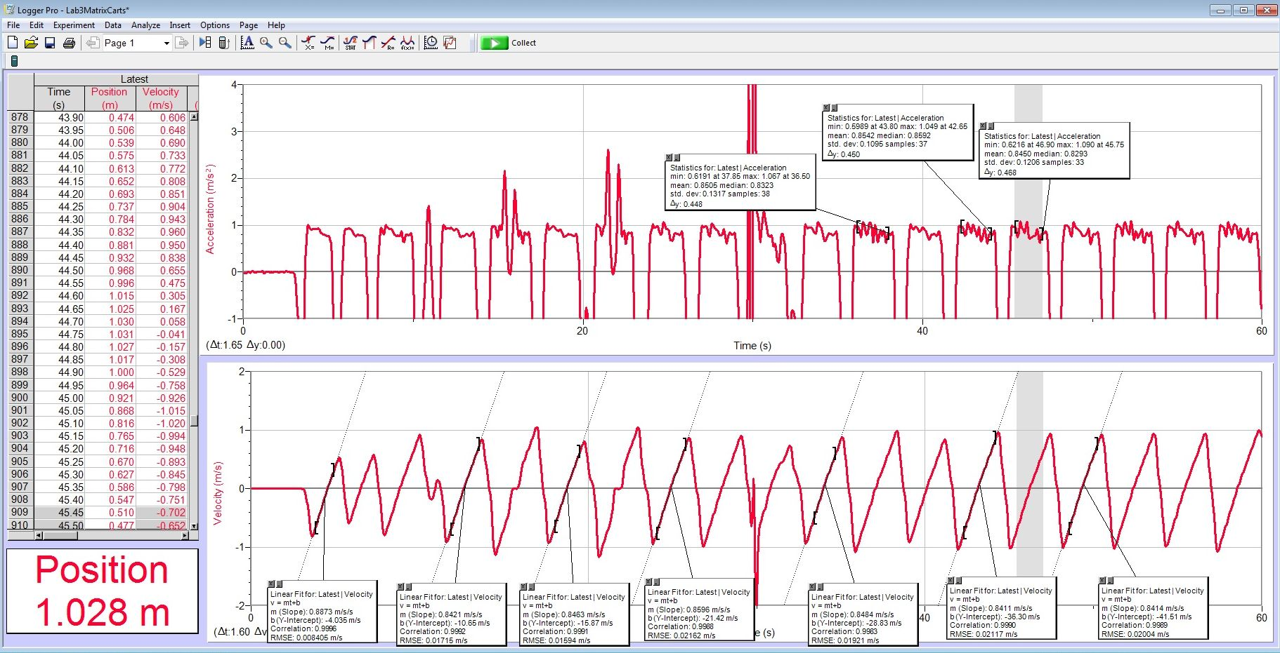

**Physics analysis**:

The central intuitive lesson to learn is that there is a clear connection between the change in velocity the cart experiences and the force causing that change. You have applied Newton’s 2nd law, and hopefully have seen that clear connection verified by the calculations you performed.

**Make sure that you have copied and pasted your analysis into your Word Document.**

**Activity 2: Measuring different accelerations:**

Since you have the ability to predict the acceleration of the carts for any combination of masses and angles, redo the experiment for 5 different values of the m2. You will now have a functional relation that you can plot *a*(m2) Plot your results in Excel and add a trend line.

Record in Excel: m2 ________ *a*predicted:_______ *a*measured:_____ %error:_________

The figure below shows the acceleration determined for 5 different masses:

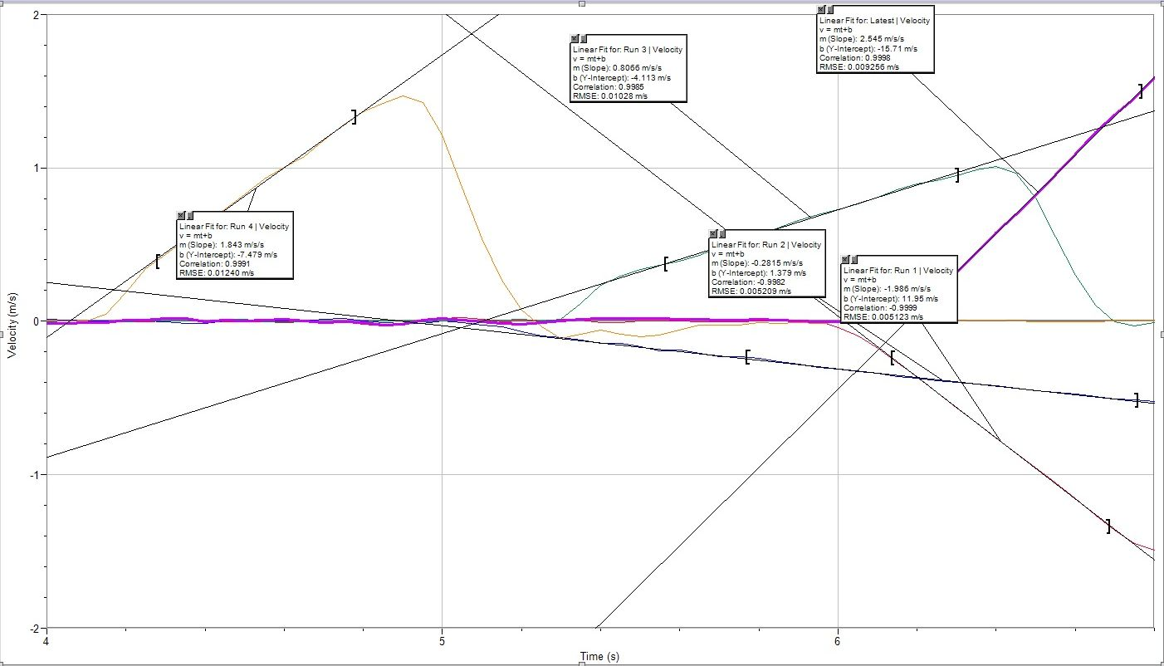

**Activity 3: Playing with the ideas**:

Depending on your choice of masses, the cart will have either accelerated up the or down the ramp. If there was insufficient mass, the acceleration you measured would have been negative, rather than positive.

To play with the idea further, try this. Start the cart at the top of the ramp with a mass, m2, sufficient to make the cart accelerate up the ramp. Then give it an initial push back down the ramp. You should see a result very similar to what you saw last week, and similar to the figure below. Copy and paste your graphs into your Word document and describe the relationship between the velocity curve you observe, and its recorded slope during that experiment:

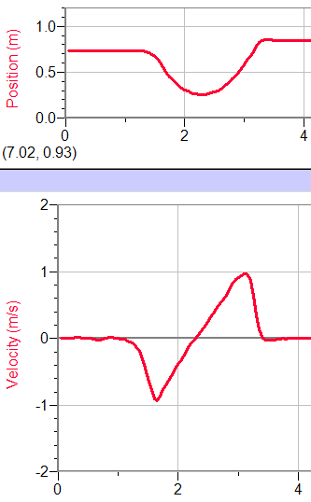

**PRINT A COPY OF YOUR WORD DOCUMENT. MAKE SURE YOUR NAME IS ON IT. TURN IT IN!**